No, static variables cannot be initialized in constructors. Static variables are associated with the class itself, not with any particular instance of the class. Because constructors are used to initialize instance variables when an object is created, they are not the appropriate place for initializing static variables.

Q can we use Static, final, public, private and protected with constructors?

**Java does not support static constructors.** Constructors in Java are inherently instance-specific and are invoked to create new instances of a class. Here's why static constructors are not allowed:

* **Instance vs. Class Level:** Constructors are meant to initialize instance variables for each new object. Static members belong to the class itself, not to any particular instance.
* **Initialization Timing:** Static initialization is handled via static blocks and static variables, which are executed when the class is loaded, not when instances are created.

#### public **Constructors**

* **Visibility:** Accessible from any other class.
* **Usage:** Allows any other class to create instances of the class.

#### private **Constructors**

* **Visibility:** Accessible only within the class itself.
* **Usage:** Restricts the instantiation of the class from outside. Commonly used in:
  + **Singleton Pattern:** Ensures only one instance of the class exists.
  + **Utility Classes:** Classes containing only static methods and fields (e.g., java.lang.Math).

public class Singleton {

private static Singleton instance;

private Singleton() {

// Private constructor

}

public static Singleton getInstance() {

if (instance == null) {

instance = new Singleton();

}

return instance;

}

}

public class Test {

public static void main(String[] args) {

// Singleton obj = new Singleton(); // Compilation Error: Constructor is private

Singleton obj = Singleton.getInstance(); // Allowed

}

}

#### protected **Constructors**

* **Visibility:** Accessible within the same package and subclasses (even if they are in different packages).
* **Usage:** Useful when you want to restrict instantiation to subclasses or classes within the same package.

#### **Default (Package-Private) Constructors**

* **Visibility:** Accessible only within the same package.
* **Usage:** When you want to restrict object creation to classes within the same package.

static blank final variable

A static final variable that is not initialized at the time of declaration is known as static blank final variable. It can be initialized only in static block.

Example of static blank final variable

class A{

  static final int data;//static blank final variable

  static{ data=50;}

  public static void main(String args[]){

    System.out.println(A.data);

 }

}

What is final parameter?

If you declare any parameter as final, you cannot change the value of it.

1. **class** Bike11{
2. **int** cube(**final** **int** n){
3. n=n+2;//can't be changed as n is final
4. n*n*n;
5. }
6. **public** **static** **void** main(String args[]){
7. Bike11 b=**new** Bike11();
8. b.cube(5);
9. }
10. }

EXCEPTION HANDLING

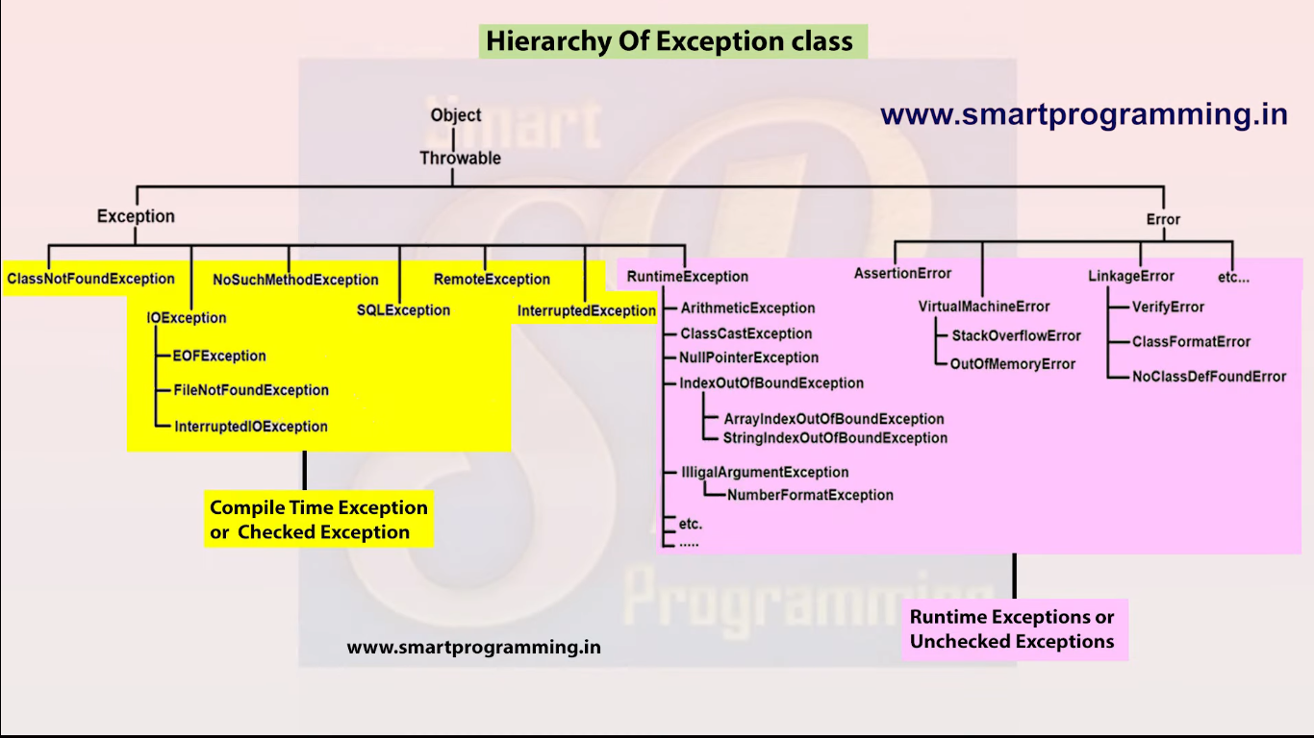

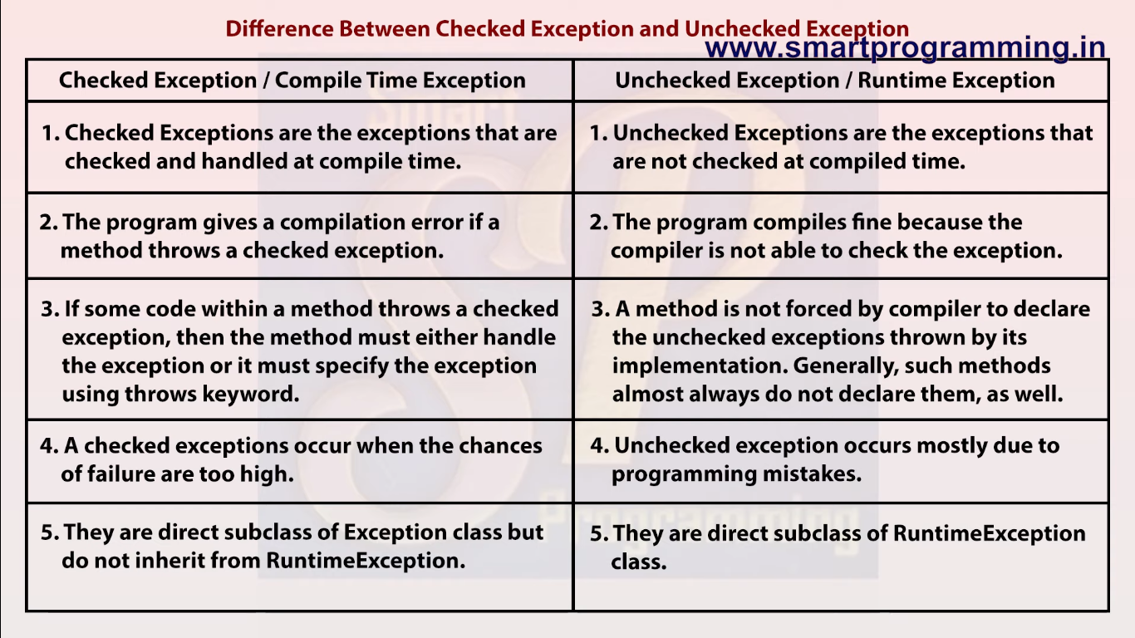

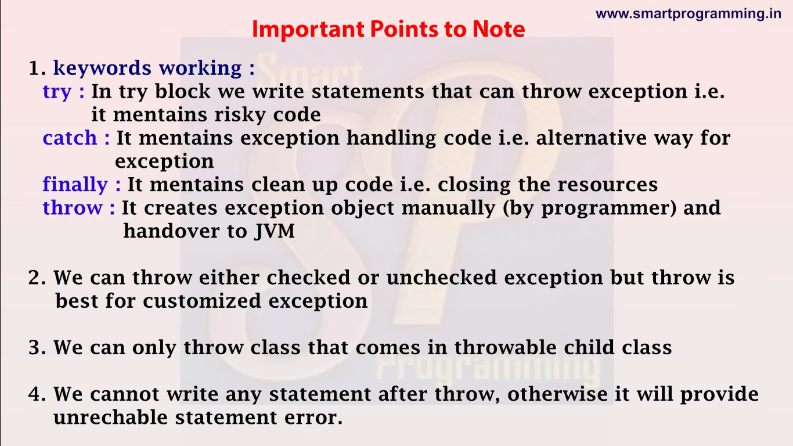

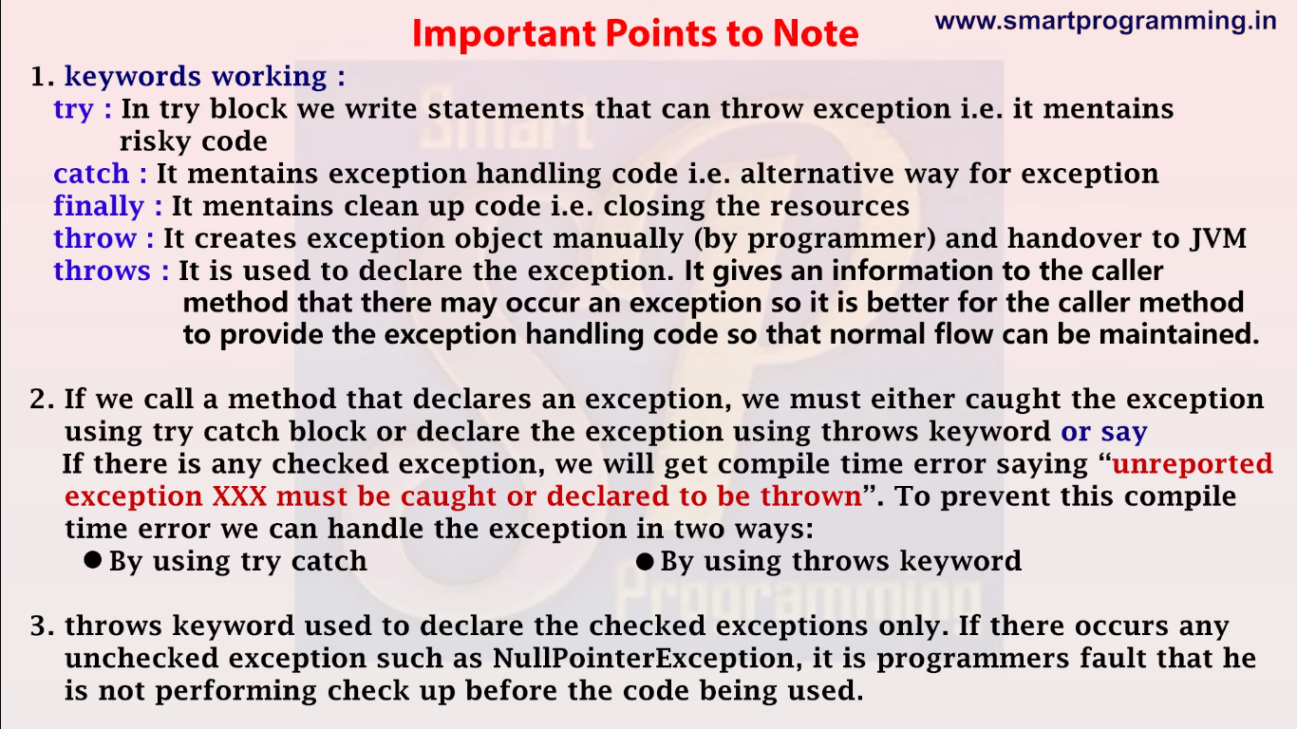

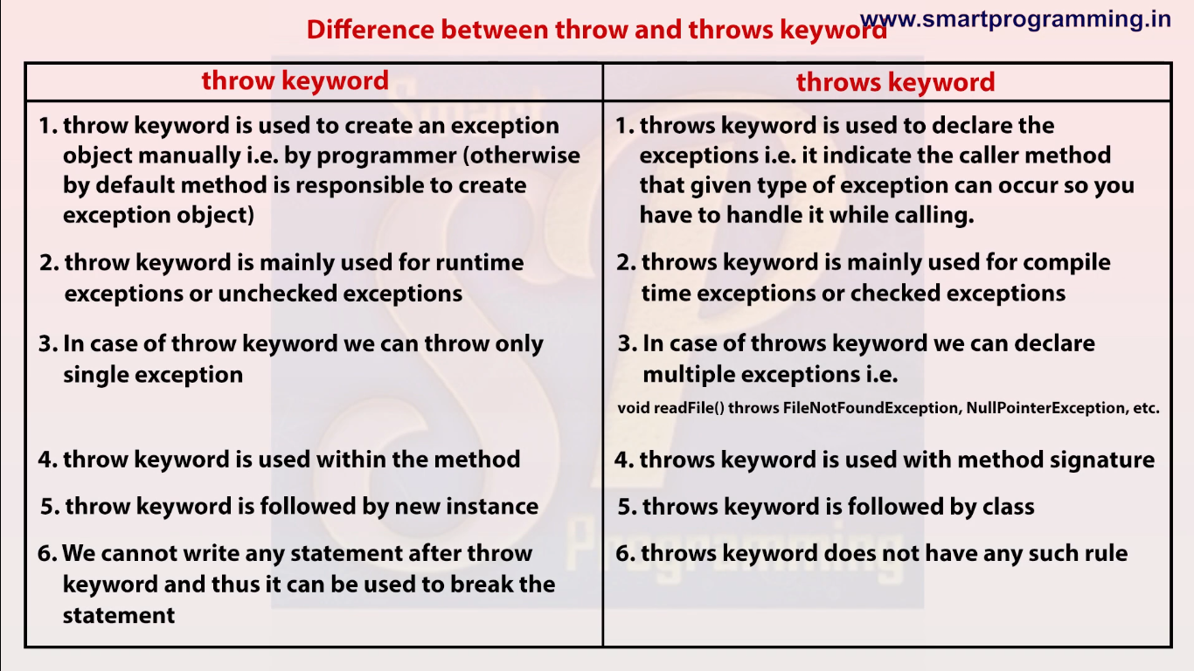

Threads (JavaTPoint)

Async programming

Lifecycle of threads:

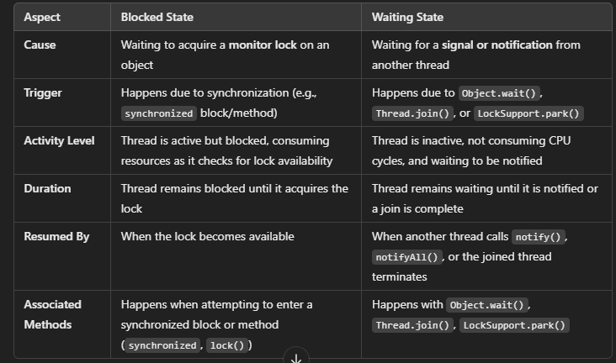

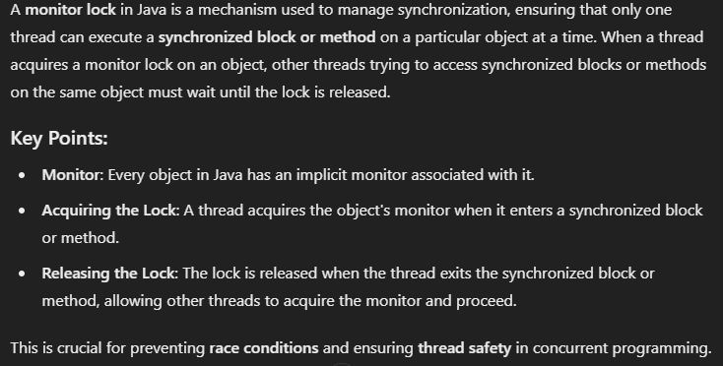

Q. Difference btw two ways of creating threads:

In Java, you can create a thread in two primary ways:

1. **By implementing the Runnable interface**.
2. **By extending the Thread class**.

Each approach has its own advantages and disadvantages. Here's a comparison of both methods:

### 1. ****Implementing the**** Runnable ****Interface****

#### Pros:

1. **Supports Multiple Inheritance**:
   * Since Java does not support multiple inheritance (a class can only extend one class), implementing Runnable allows the class to still extend another class if needed. This gives more design flexibility.
   * Example: You can have a class that extends a specific parent class and also runs as a thread by implementing Runnable.

java

Copy code

class MyClass extends AnotherClass implements Runnable {

@Override

public void run() {

// Task to be executed in a thread

}

}

1. **Separation of Task from Thread**:
   * Runnable is more flexible as it separates the **task** (what needs to be done) from the **thread** (how it will run). This allows you to use the same Runnable task with different threads or executors (e.g., in a thread pool).
   * This is beneficial when using thread management frameworks like ExecutorService or when reusing the same Runnable across multiple threads.
2. **Better for Thread Pooling**:
   * With the Runnable interface, tasks can easily be reused in a **thread pool** (where threads are managed automatically, and tasks are distributed among the threads), improving resource management and reducing thread overhead.
3. **Encourages Code Reusability**:
   * Implementing Runnable makes your code more modular, as it separates the task's logic from thread management. You can pass the Runnable instance to any thread and reuse it in different contexts.

#### Cons:

1. **Less Direct**:
   * To start a thread, you need to create an instance of Thread and pass the Runnable object to it. This requires one additional step compared to extending the Thread class.

java

Copy code

Thread thread = new Thread(new MyRunnable());

thread.start();

### 2. ****Extending the**** Thread ****Class****

#### Pros:

1. **Simpler to Use**:
   * Extending Thread is easier and more straightforward for simple tasks, as you can directly call the start() method on the thread instance.

java

Copy code

class MyThread extends Thread {

@Override

public void run() {

// Task to be executed in a thread

}

}

MyThread thread = new MyThread();

thread.start();

1. **Can Override Thread Methods**:
   * When you extend Thread, you have the ability to override other Thread class methods like start(), interrupt(), etc., if needed. This gives more control over the thread's lifecycle and behavior.

#### Cons:

1. **Cannot Extend Other Classes**:
   * As Java supports **single inheritance**, extending the Thread class prevents your class from extending any other class. This can be restrictive if your class needs to inherit from another class for some functionality.

java

Copy code

// Not possible because Java does not allow multiple inheritance

class MyThread extends AnotherClass, Thread {

}

1. **Task and Thread Are Tightly Coupled**:
   * When you extend Thread, the task (logic in the run() method) is tied to the thread itself, which reduces flexibility. If you need to run the same task in multiple threads, you have to create a new Thread instance each time, which makes it less reusable and less efficient.
2. **Less Suitable for Thread Pooling**:
   * Thread pooling (using thread pools with ExecutorService) is more complicated when extending Thread. Since Runnable is preferred in such cases, extending Thread makes the code harder to integrate with such frameworks.

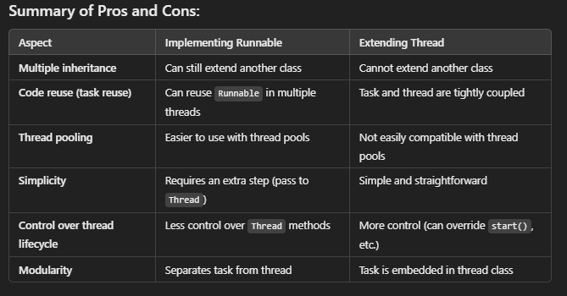

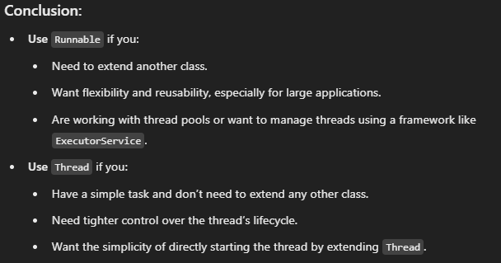

1. which way of creating thread is better?

Ans. Implementing runnable interface is better for industry standards as in industry doing inheritances is a very common practise

Now u want to make a new class A which extends B and want to make thread from class A.

Case 1 : when u extended tread class using class C

Class A extends B,C (can not do it as Multiple inheritance is not supported)

Case 2 : when implemted runnable interface using class C

Class A extends B implements C (this is possible)

2. can a thread in dead state be made alive again or can we call start method twice.

Ans No, a thread in dead state can not be made alive again and using start function again will give

IllegalThreadStateException

3. what is use run() method instead of calling start()?

Ans run method will run but a thread will not be created for it.

4. when will a thread is created, when i make and object of the class extending thread class or when i call start method on the object

When you extend the Thread class and create an object of that class, **the thread is not created yet**. The thread is created and begins execution only when you call the start() method on the object.

At this point, the object is just a regular Java object, not an active thread

• **Before calling start()**, the object is just a plain Java object, and no thread has been created.

• **After calling start()**, a new thread is created, and the run() method of the Thread class (or its subclass) is executed in that new thread.

5. when does thread go into dead state? Also what happens to the object when thread goes in dead state?

Ans when a thread completes the execution of its run() method (not the start() method), it enters the **dead state**. In the dead state, the thread has finished its execution and cannot be restarted.

• **New**: A thread is in this state when it is created but the start() method has not been called yet.

• **Runnable**: After calling the start() method, the thread is ready to run. The thread enters the runnable state, waiting for the CPU to schedule its execution.

• **Running**: The thread is actually executing its run() method (or the code it is supposed to run).

• **Blocked/Waiting** (optional): During its execution, the thread may enter a blocked or waiting state if it is waiting for some resource (like I/O operations) or waiting for another thread to complete.

• **Terminated (Dead)**: Once the thread has finished executing its run() method, it enters the **dead state**. A dead thread cannot be restarted.

When the thread enters the dead state, **the Thread object itself still exists**, but the thread it represents can no longer perform any thread-related tasks. The thread's execution is complete, but the object is still in memory like any other object in Java, and it will remain in memory until there are no more references to it (after which it may be garbage collected).

The object that represents the thread still exists, and you can call methods on it (like getName(), isAlive()), but you cannot restart the thread by calling start() again. If you try to call start() on a dead thread, you'll get an IllegalThreadStateException.

6. Can I overload Run() method?

You **can** overload the run() method with different parameters, but the overloaded versions will not be invoked when the thread starts using the start() method. Only the no-argument run() method will be executed in the new thread. If you want to use the overloaded versions, you'll have to call them explicitly, but they will not run in a separate thread. (So you can but it is useless)

7. Constructors and methods in Thread class

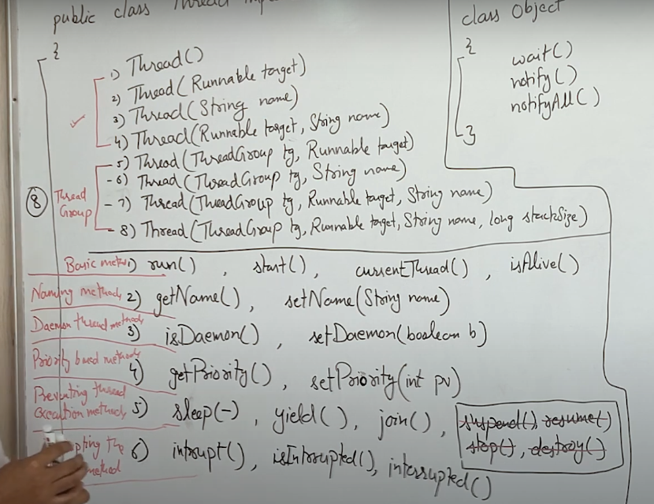

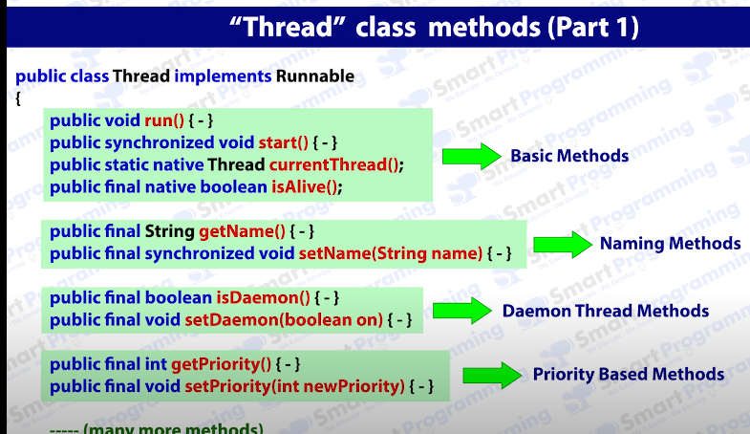

Start() method is synchronized.

CurrentThread() and isAlive() method are native methods which means its implementation is done in some other language then JAVA

CurrentThread() is static.

To set a thread as Daemon thread use setDaemon(1)

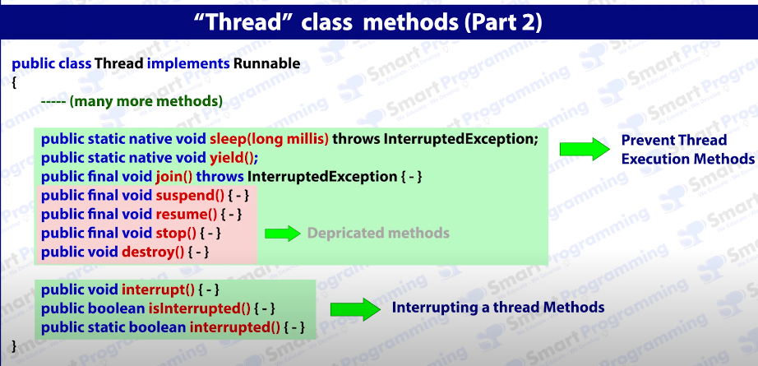

Sleep() and yield are Native methods

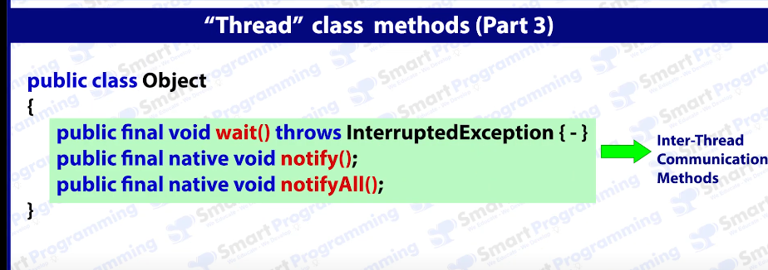

These methods are not part of Thread class but they work on threads for Inter-Thread Communication.

8. What are Daemon Threads?

**i Def:** Which runs in background of another thread

**ii Use:** It provides service to the threads

**iii Ex:** Garbage collector, finalizer, Attach Listeners, Signal Dispatchers

Garbage Collector: it runs in bg of main thread and if suppose main tread encounters problems like memory leak or memory full then it is the duty of GC to resolve it(free up unused memory) and re-runs the main thread.

Spelling Checker: it keeps working in the bg and underlines the wrong spelling. (in MS word)

**iv Methods:**

public final void setDaemon(Boolean b),

public final boolean isDaemon()

**V.Q** How to Create a Demon thread? (DaemonThread in Threads folder)

**V ans.** Extend class as usual and create its object. Now before Calling the start() method, use setDaemon(1). If we create daemon thread after starting it, it will throw run-time exception i.e. IllegalThreadStateException

Therefore, we cannot create main thread as daemon thread.

Psvm(){

Thread.currentThread().setDaemon(1) // IllegalThreadStateException

}

**vi. Life:** Its life depends on Parent thread. When Parent thread dies, daemon thread also dies.

**vii. Nature:** (This point is valid for all the threads) It inherits the nature and properties from its parent Thread. Meaning a child thread byDefault will be Daemon or not, its priority all are inherited from parent thread.

**viii. Role of JVM:** JVM waits for all the threads to finish execution but not for daemon threads. This means if only Daemon thread is running then JVM kills the Daemon thread.

The sole purpose of the daemon thread is that it provides services to user thread for background supporting task. If there is no user thread, why should JVM keep running this thread. That is why JVM terminates the daemon thread if there is no user thread.

**ix. Low Priority:**  Most of the times Daemon threads have low priority but we can change the priority according to our needs.

**9. Priorities**

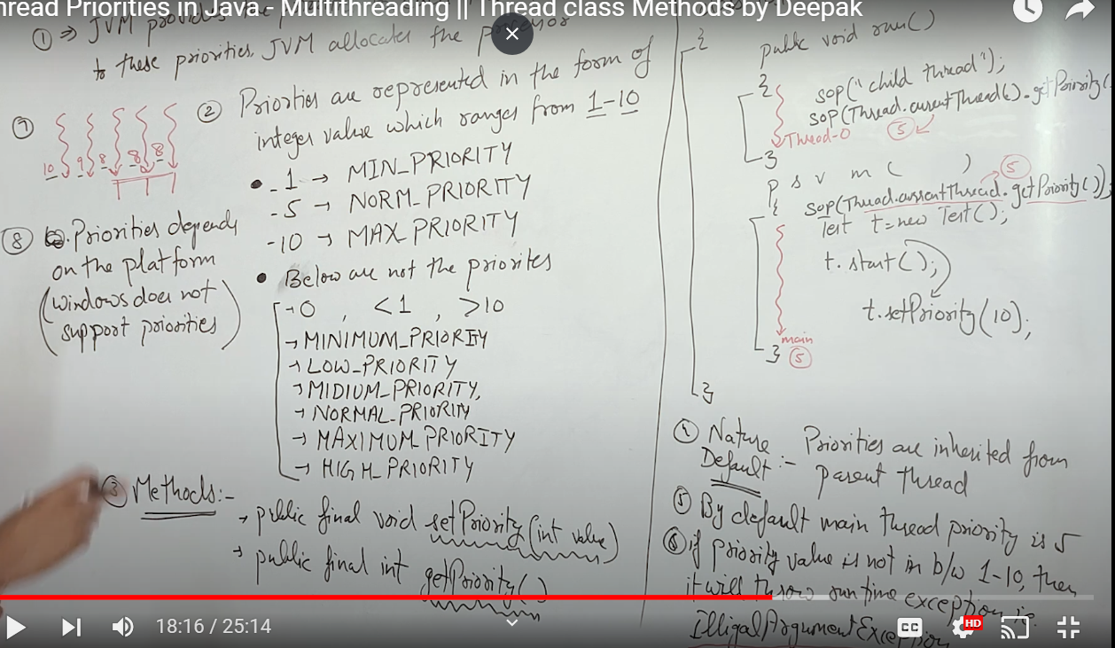

1. JVM provides the priorities to each thread and according to these priorities JVM allocates the processor

7. when priorities are same(here 3 threads have 8) JVM uses its own set of algorithms to give processor to them. We cannot predict them.

**10. Sleep() Method:**

Public static native void sleep(long mili) throws InterruptedException

-native means its implementation is in some other language other than JAVA

-Its is a checked Exception means I need to either use a try catch block or write throws InterruptedException

Public static void sleep(long mili, int nanos) throws InterruptedException

-nanos: This is the additional time in nanoseconds for which we want the thread to sleep. It ranges from 0 to 999999.

**Q Why Use the nanos Parameter?**

The need for the nanos parameter comes down to **precision**. While the Thread.sleep(long millis) method allows you to specify delays in milliseconds, sometimes you might need finer control over the sleep duration—down to nanoseconds. This can be particularly useful in applications that require very fine-grained timing.

• **High-precision applications**: In systems where timing is critical, such as certain real-time applications, simulations, or multimedia processing (audio/video sync), the ability to sleep for an exact duration down to the nanosecond can be important.

• **Scheduling finer tasks**: If you're building a system that schedules tasks that need to run at very specific intervals, the nanosecond precision helps achieve closer control over those intervals.

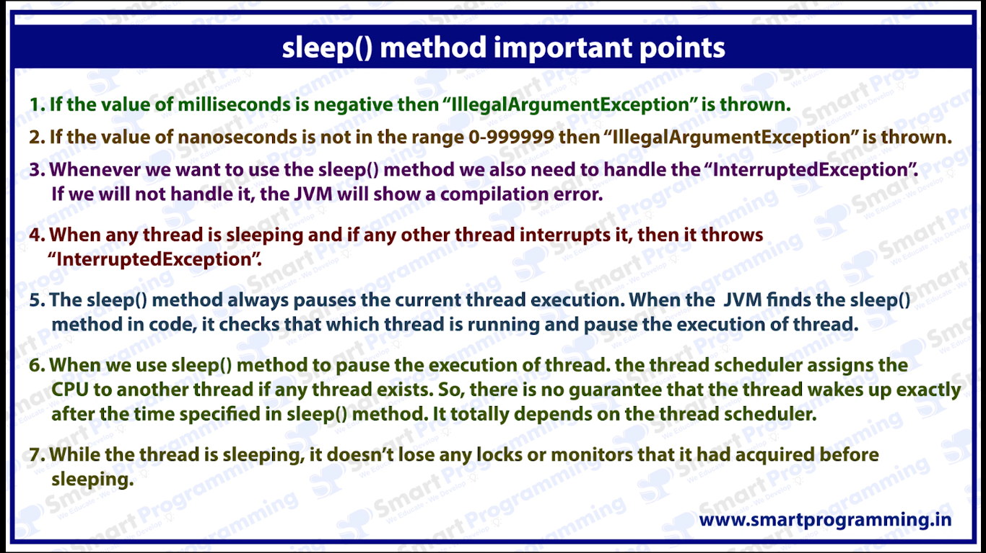

When a thread calls Thread.sleep(), it enters the **TIMED_WAITING** state for a specified period. During this time, the thread is inactive and not consuming CPU resources, but it is still alive. The thread will stay in this state until:

* The specified sleep duration elapses, after which the thread transitions back to the **RUNNABLE** state.
* It is interrupted by another thread calling interrupt(), which causes the thread to wake up immediately and throw an InterruptedException.

11. Yield:

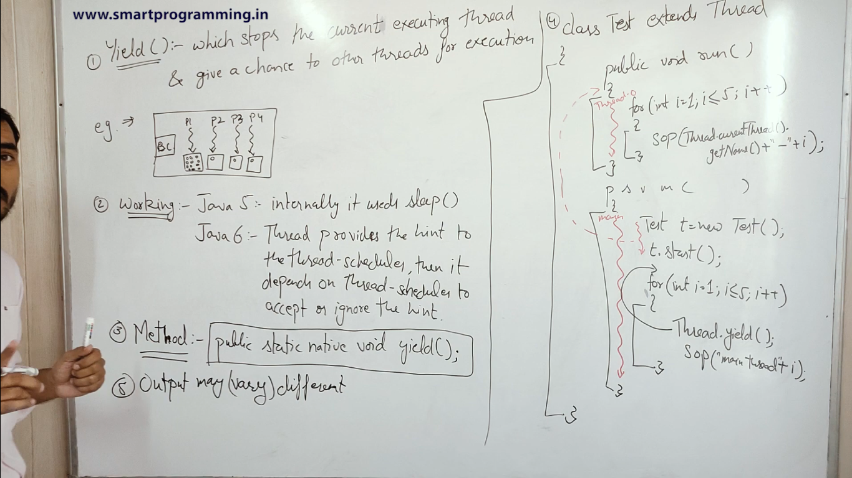

Example: Billing Counter, P1 has lots of items in his cart while rest have very few.

So other threads request P1 to give them preference but it is upto P1 wheter he will allow it or not.

NOTE:

In Java, the yield() method from the Thread class is a way for a thread to signal to the scheduler that it is willing to pause its execution and allow other threads with the same or higher priority to execute. However, there are a few important points to understand:

1. **Priority Doesn't Guarantee Scheduling**: The priority of a thread is just a hint to the thread scheduler. Threads with higher priority are more likely to be chosen for execution, but there is no guarantee. Similarly, when a thread calls yield(), it doesn't guarantee that a higher-priority thread will be selected to run next. The thread scheduler may continue running the same thread, depending on its internal logic and the platform's specifics.
2. **Other Threads’ Priorities**: The yield() method allows other threads of the same or higher priority to run. So, it is not necessary for the other threads to have a priority greater than the thread that called yield(). Threads with **equal or higher** priority may be scheduled next.
3. **Platform and JVM Dependent**: The behavior of yield() can vary between different platforms and JVM implementations. Some JVMs may not give much weight to thread priorities, and yield() may not behave as expected in certain situations.

12. Join():

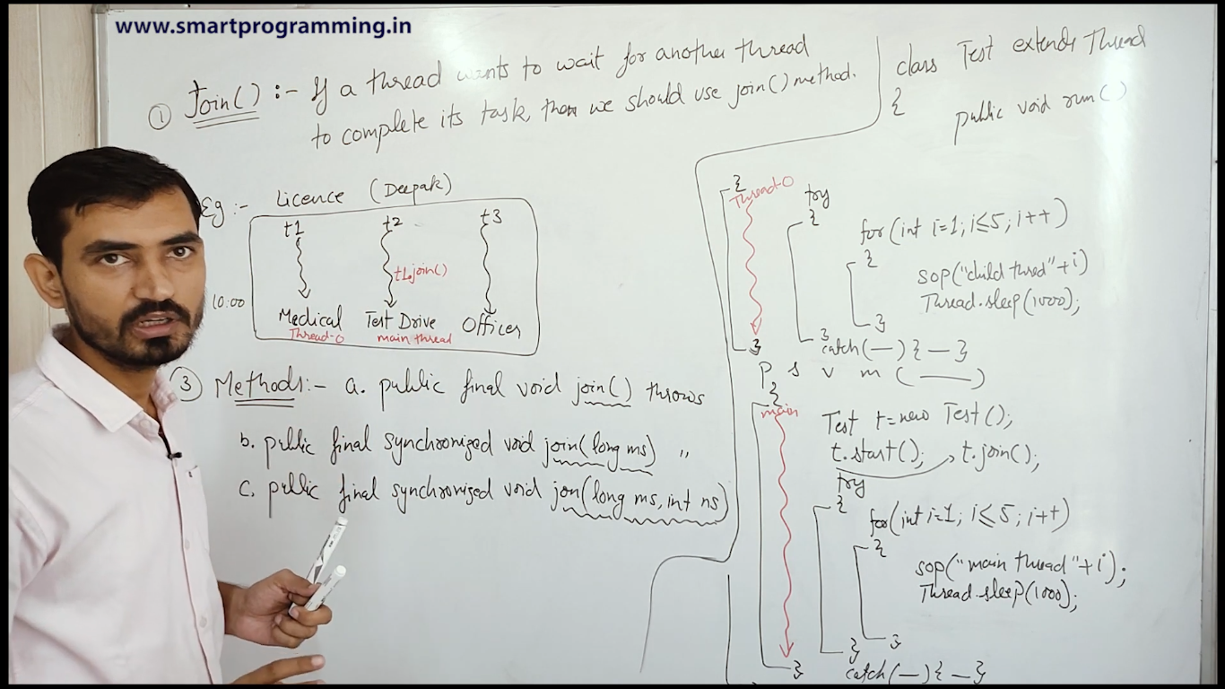

3a When the join() method is invoked, the current thread stops its execution and the thread goes into the wait state. The current thread remains in the wait state until the thread on which the join() method is invoked has achieved its dead state. If interruption of the thread occurs, then it throws the InterruptedException.

3b means join will wait for the defined amount of time to let other thread complete its work but if other thread does not complete in in defined amount of time then it will start execution.

Or

When the join() method is invoked, the current thread stops its execution and the thread goes into the wait state. The current thread remains in the wait state until the thread on which the join() method is invoked called is dead or the wait for the specified time frame(in milliseconds) is over.

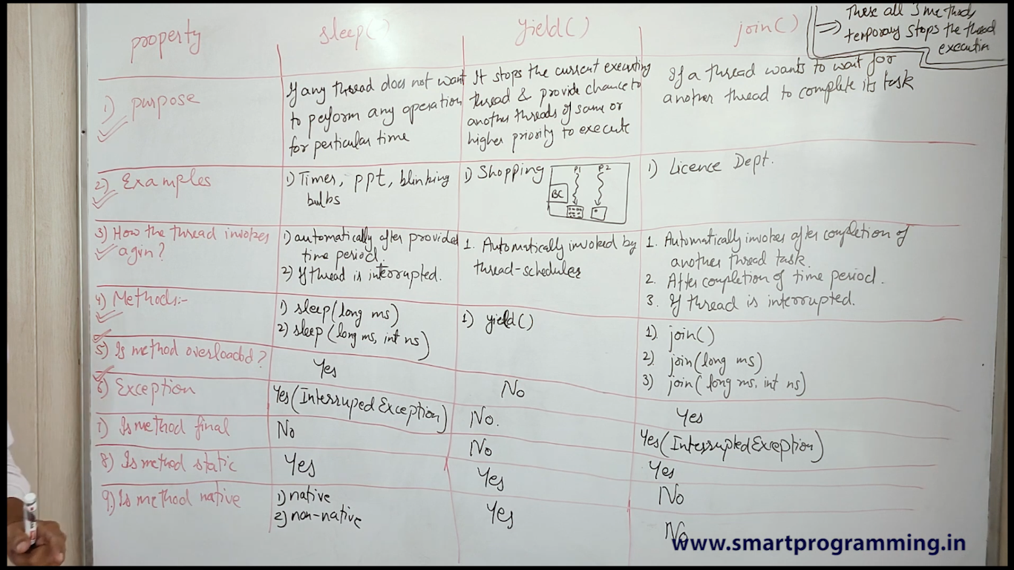

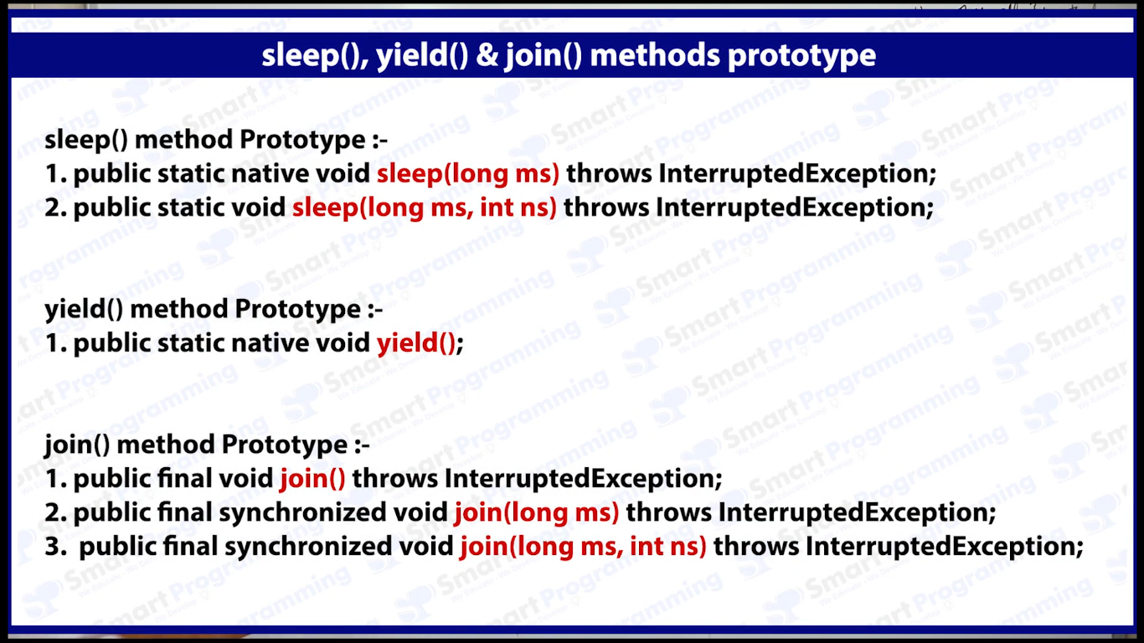

Prototypes of methods can help u remember a lot of points regarding methods so do revise.

13.Interrupted()

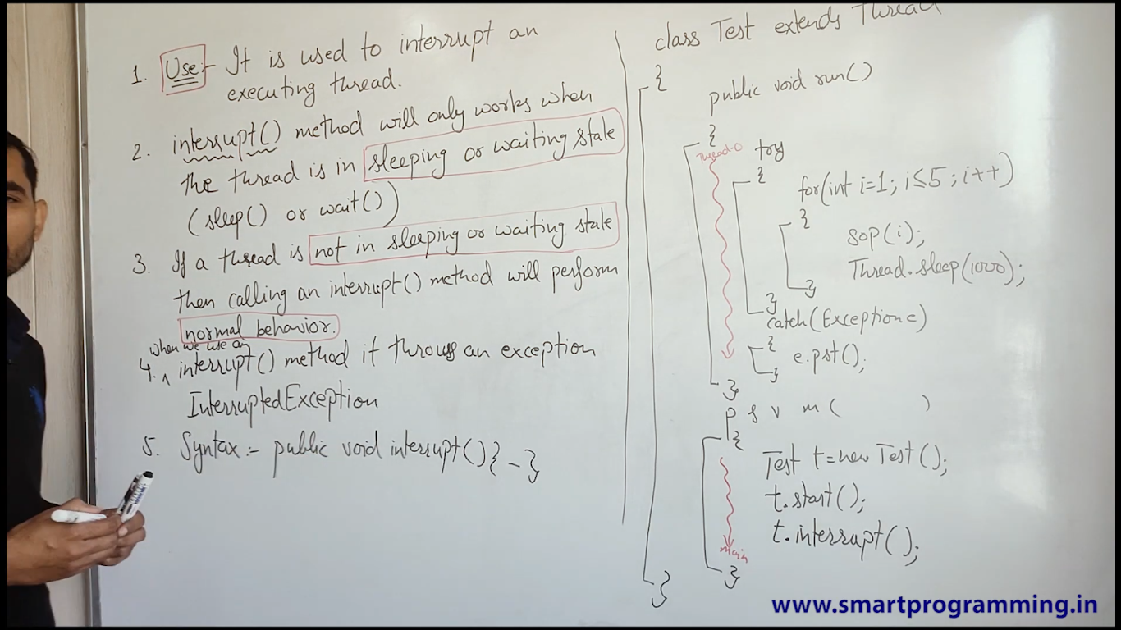

### ****Running Threads Must Check for Interrupts Manually****

If a thread is in the **running** state, calling interrupt() doesn’t force the thread to stop or exit. Instead, it sets the thread’s "interrupted" flag, which the running thread must check manually by calling Thread.interrupted() or isInterrupted().

The thread has to cooperate and check for interrupts during its execution. If it doesn’t check the interrupt flag, the interrupt() method has no immediate effect.

14. isInterrupt() vs Interrupted()

Inter Thread Communication

